First Terminal Examination – 2081
Specification Grid 2081
F.M.: 50
P.M.: 18
Number of Questions
S.N. | Name of Chapter | 1 mark | 2 mark | Total
1 | We and our life
 | capacity |  | 2 | 4
2 | We and our daily time
 | Time
3 | My creativity
 | Geometry |  | 2 | 4
4 | Concept ofnumbers 1
 | Number from 1 to 500 | 2 |  | 2
 | Expanded and short form |  | 2 | 4
 | Comparision of numbers |  | 4 | 8
5 | Basic operation of numbers
 | Addition of 2 digit numbers |  | 3 | 6
 | Subtraction of 2 digit numbers |  | 3 | 6
 | Addition and subtraction of 3 digit numbers 1
 | Total | 2 | 24 | 50

Second Terminal Examination – 2081
Specification Grid 2081
F.M.: 50
P.M.: 18
Number of Questions
S.N. | Name of Chapter | 1 mark | 2 mark | Total
1 | We and our life
 | capacity |  | 1 | 1
2 | We and our daily time
 | Time/calendar
3 | My creativity |  | 1 | 2
 | Geometry |  | 1 | 2
4 | Concept of numbers 1 and 2
 | - Devanagari numbers | 1 |  | 1
 | - Expanded and short form |  | 2 | 4
 | - Comparision of numbers | 1 |  | 1
 | - Number before and after |  | 2 | 4
 | - Increasing and decreasing order
5 | Basic operation of numbers 1 and 2
 | - Addition of three digit numbers
 | (Carry over) |  | 2 | 4
 | - Subtraction of three digit numbers
 | (Borrowing) |  | 2 | 4
 | - Word problem |  | 2 | 4
6 | Our community
 | - Comparison of numbers (><=) | 3 |  | 3
 | - Even and odd numbers |  | 2 | 4
 | - Volume |  | 2 | 4
 | - Weight |  | 2 | 4
 | Total | 6 | 22 | 50

Third Terminal Examination – 2081
Specification Grid 2081
F.M.: 50
P.M.: 18
Number of Questions
S.N. | Name of Chapter | 1 mark | 2 mark | Total
1 | We and our life
 | capacity | 1 |  | 1
2 | We and our daily time
 | Time | 1 |  | 1
3 | My creativity
 | Geometry |  | 2 | 4
4 | Concept of numbers 1 and 2
 | - 501 to 1000 |  | 1 | 2
 | - Place value of the digits |  | 1 | 2
 | - Expanded and standard form |  | 2 | 4
5 | Basic operation numbers 2
 | - Addition and subtraction of 3 digits number |  | 2 | 4
 | - Word problem |  | 1 | 2
6 | Our community
 | - Comparison of numbers |  | 2 | 4
 | - Even and odd numbers |  | 1 | 2
 | - Volume |  | 1 | 2
 | - Weight
7 | My School
 | - Measurement |  | 2 | 4
 | - Multiplication 1 |  | 2 | 4
 | - Fraction |  | 2 | 4
8 | Commuinication, Technology and Money
 | - Pictograph | 4 |  | 4
 | - Money |  | 2 | 4
 | Total | 6 | 22 | 50

Annual Examination – 2081
Specification Grid 2081
Time: 2 hrs.
F.M.: 50
P.M.: 18
Number of Questions
S.N. | Name of Chapter | 1 mark | 2 mark | Total
1 | We and our life
 | capacity | 2 |  | 2
2 | We and our daily time
 | Time/calendar |  | 2 | 4
3 | My creativity | 1 | 2 | 5
 | Geometry
4 | Concept of numbers
 | - Numbers from 501 to 1000 | 1 |  | 1
 | - Place value |  | 2 | 4
5 | Basic operation of numbers
 | - Addition of three digit numbers (carry over) |  | 1 | 2
 | - Subtraction of 3 digit numbers (Borrowing) |  | 1 | 2
 | - Word problem
6 | Our community
 | - Comparison of numbers | 3 |  | 3
 | - Even and odd numbers | 1 | 1 | 3
 | - Volume |  | 1 | 2
 | - Weight |  | 1 | 2
 | - Weight |  | 1 | 2
7 | My School
 | - Measurement/Perimeter/Area | 2 |  | 2
 | - Multiplication |  | 1 | 2
 | - Fraction (All) |  | 1 | 2
8 | Communication, Technology and Money
 | - Pictograph |  | 2 | 4
 | - Money |  | 1 | 2
9 | Basic operation of numbers 3
 | - Multiplication 2 |  | 2 | 4
 | - Division |  | 2 | 4
 | Total | 10 | 20 | 50

Model Questions
First Terminal Examination – 2081
Time: 2:00 hrs
Class – 2 F.M.: 50
Subject – C Math P.M.:18

- Tick (√) the vessal with more capacity. 2


- Cross () the vessel with less capacity. 2


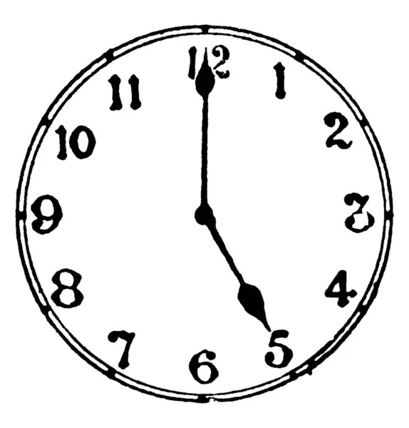
- Write the time in two ways. 2
………………………… o clock
……………….. : ……………

- Complete the following. 2
2:10 means ……………………………………………. Minutes past ………………………………… o'clock.

- Measure the length of follwing line segment using rular. 2

ii)
- Write the geometrical name of following shapes. 2

……………………………………
……………………………………

- Fill the missing numbers in the box. 2x2=4
62 |  |  | 65 |  |  | 68

125 |  |  | 128 |  |  | 131

- Write in number. 2
Four hundred and thirty five……………………………………
Three hundred and seven………………………………………..
- Write the numbers name. 2
375 =…………………………………………………………………………………..
270=……………………………………………………………………………………….
- Write in devanagari numbers name. 1
$^)=============================================================================================================

- Write in expanded from. 2
285 =………………………………………………………………………….
- Write in standard form. 2
700 + 30 + 1 =…………………………………………………..
- Circle (O) the greatest number. 2x2=4
- 169 219
- 415 405
- Circle (O) the smallest numbers. 2x2=4
i) 232 311
ii) 225 180
- Addition. 2x2=4
43
+22
63
+14

- Rojina has 45 mango, Lochan has 35 mango, how do they have altogether. 2
- Subtraction. 2x2=4
36
-13
66
-33

- Bijay collected 29 stemps. He gave 18 stamps to his friend.
How many stamps are left with him? 2
- Addition and Subtraction. 4
358
-136
322
+135

- Write in devanagari numbers name. 1
$@% …………………………………………………….………….

Model Questions
Second Terminal Examination – 2081
Time: 2:00 hrs
Class – 2 F.M.: 50
Subject – Math P.M.:20

- Tick the vessal with more capacity. 1

- How many months are there in a year? 2

- Draw the following shaps.
- Circle
- Square

- Write in devanagari numbers.
345 …………………………………………………………….………..
- Write in expanded form.
254 ………………………………………………………………………….
- Write in short form.
600 + 30 + 5 =………………………………………..
- Tick the greater numbers.
413 460
- What comes before? 2
376

647

- ii)

- What comes after? 2
839

480

- ii)

- Write the numbers in the increasing order.
- 163 147 129 149
- 370 396 364 310
- Write the number in the decreasing order.
- 270 376 368 303
- 409 449 440 425
- Addition
483
148
+263
131
269
+283

- Subtraction. 2x2=4
341
-127
439
-149

- There are 137 boys and 212 girls in a school. How many students are there altogether? 2
There are
- Sita had Rs. 437 she spent Rs. 126 for shopping. How much money is left with her? 2
Rs. is left with her.
- Put <, = or > in the given boxes. 3
248 317
423 413
275 275
- Circle the even numbers. 2
- 25 26
- 45 46
- Circle the odd numbers. 2
- 113 114
- 270 271

